Name: Mriganka Patra

Email: [mriganka.patra@cognizant.com](mailto:mriganka.patra@cognizant.com)

Emp ID: 2415820

Day 18

Sprint 1 Submission

Objective: Implement the baes CRM logic with record types, automation, visibility settings, and uesr management

Task 1.4: As an admin I want to set visibility rules for data so that users only see records relevant to their role.

1. Go to setup > home
2. Search for sharing settings
4. 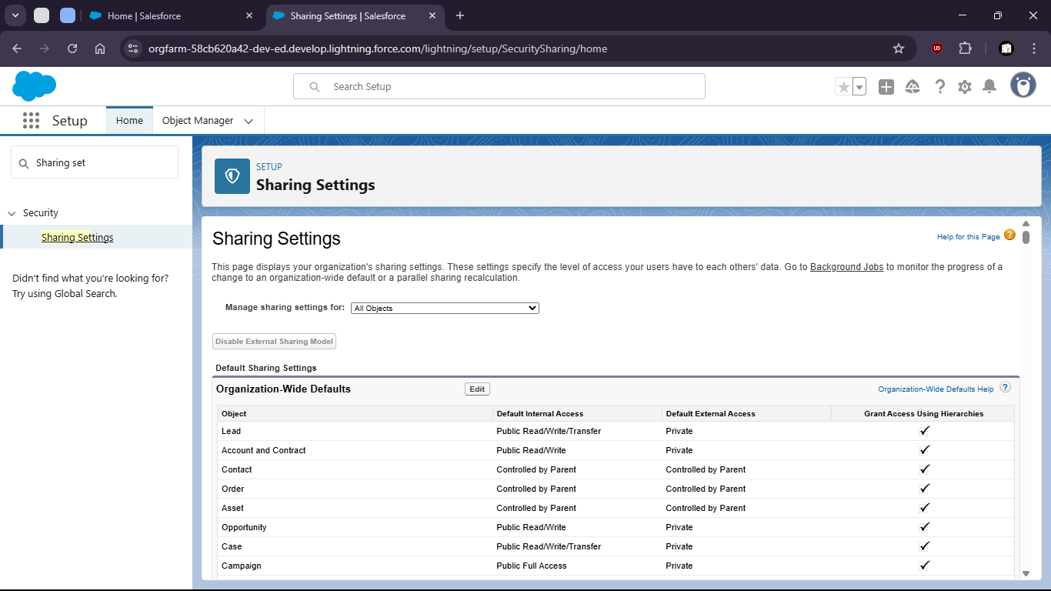
6. Make changes to org wise defaults
8. 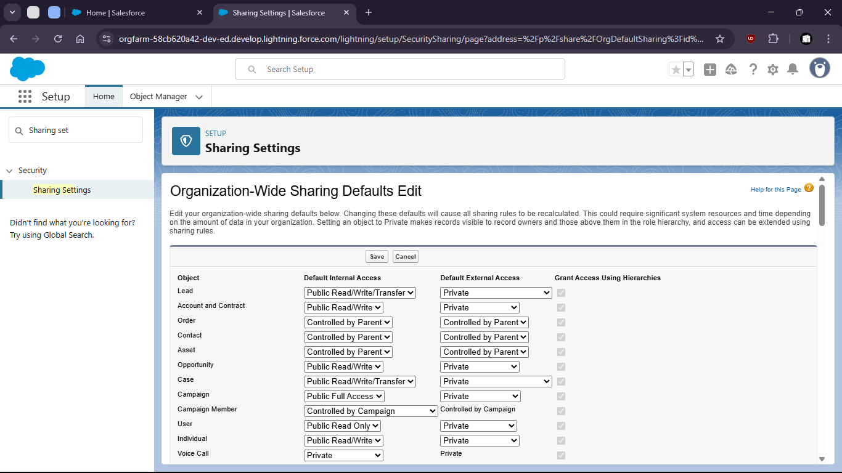
10. Now goto home > Roles
12. 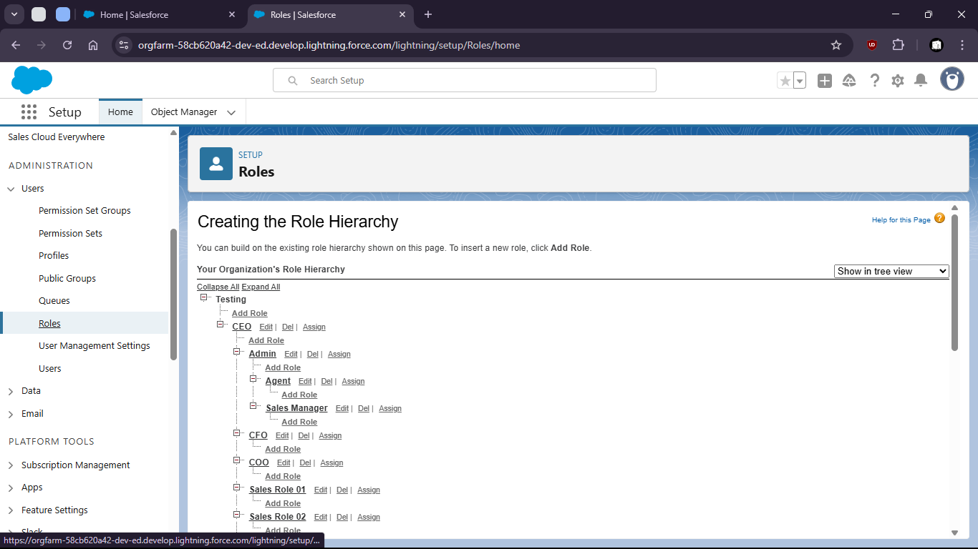
14. Set up roles under CEO as Admin
16. 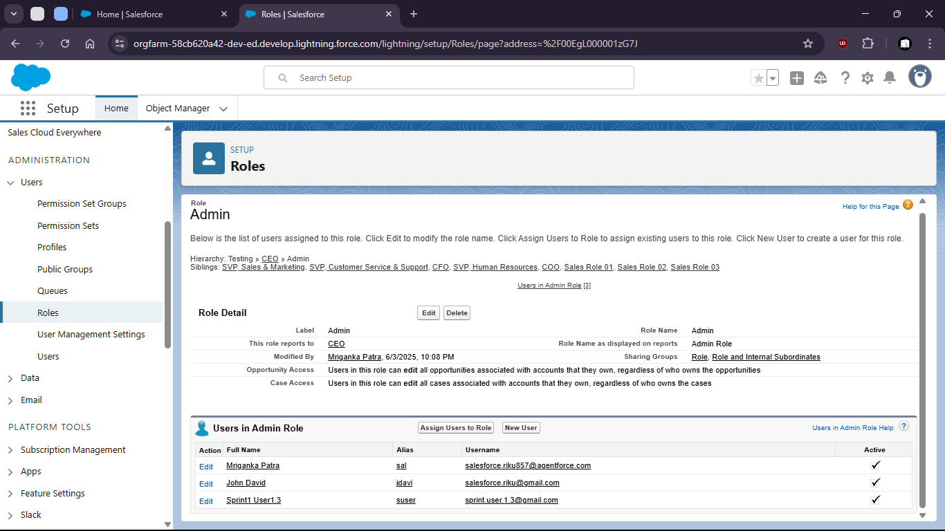
18. Look for assigned users to this role
20. 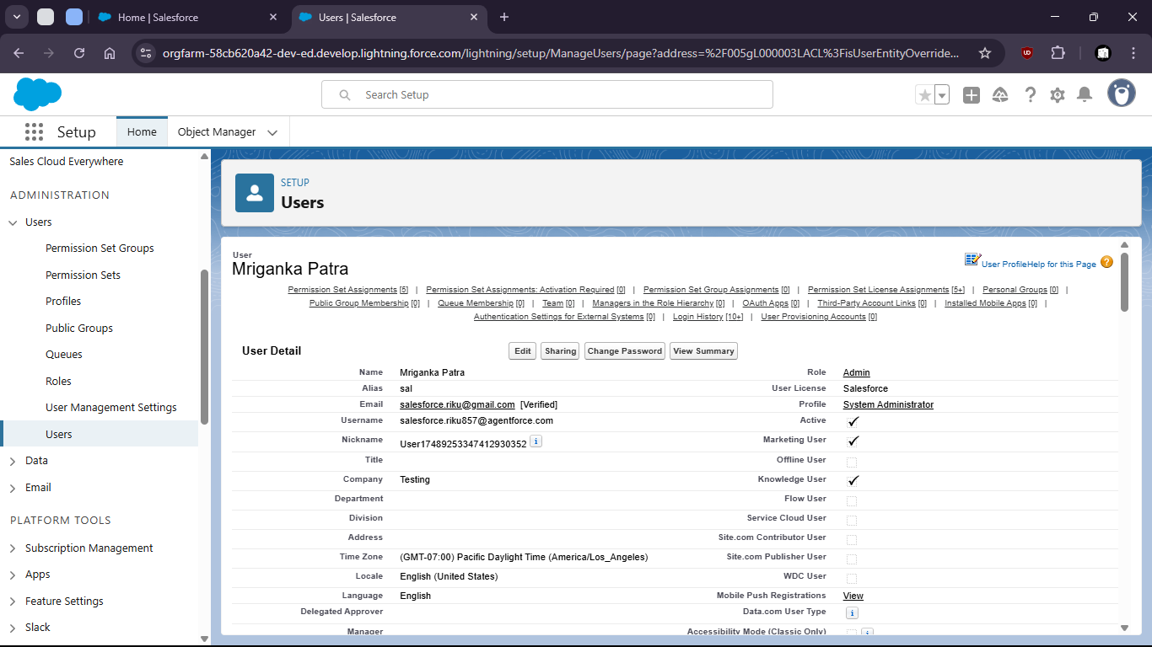
22. For the assigned users in that Role create a sharing rule
24. 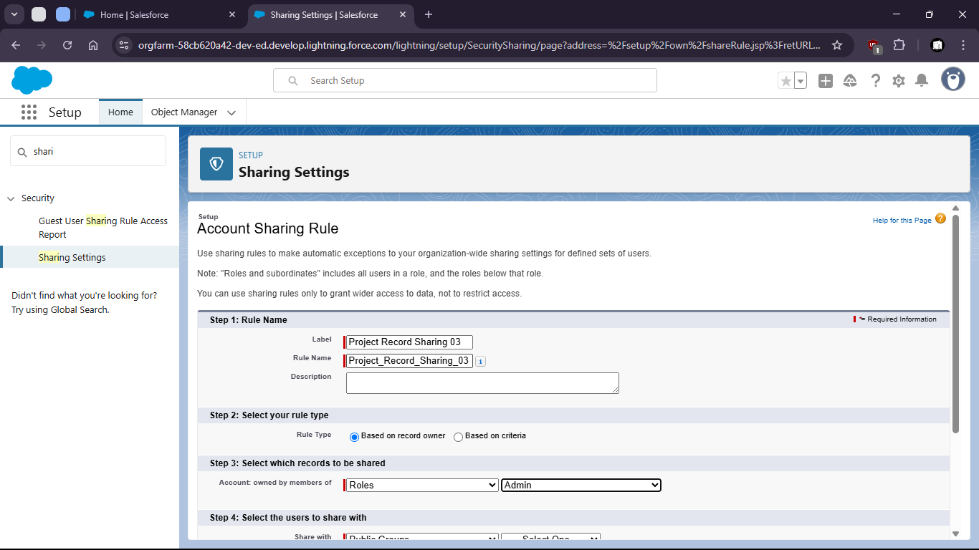
26. 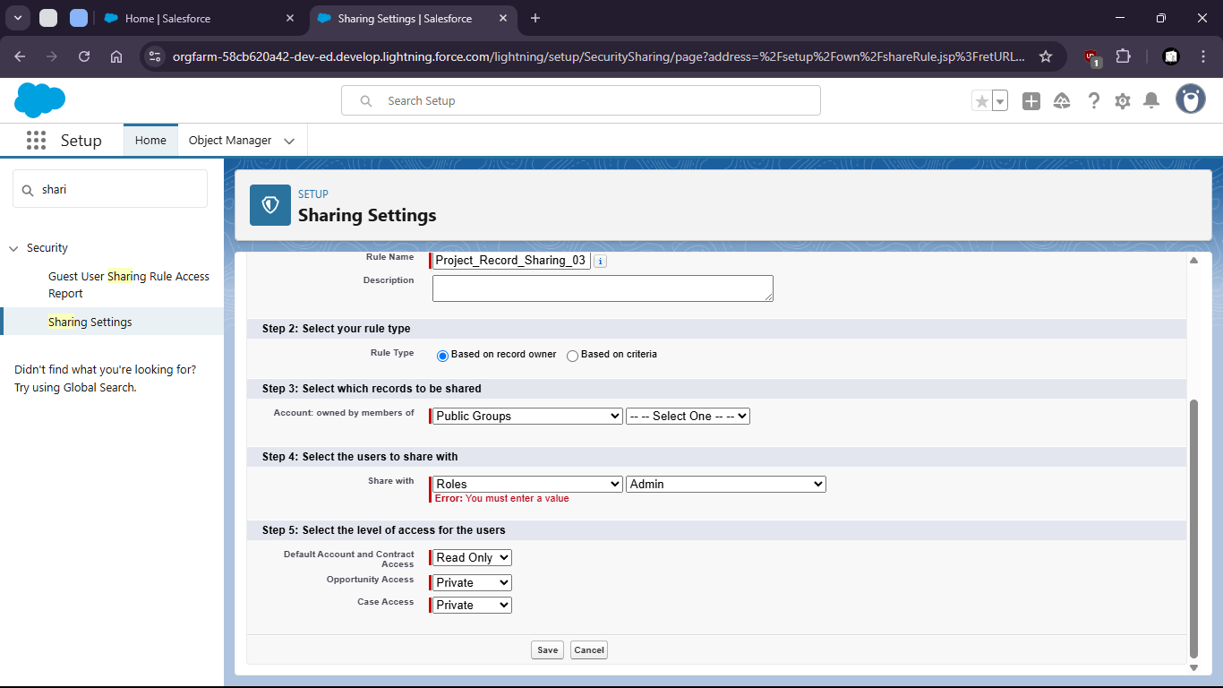
27. 